ROBOT MOVEMENT CONTROLLING USING ANDROID

AIM:
The main aim of the project is to design a wireless controlled Robot using android mobile with the help of Bluetooth.
PURPOSE:
The purpose of the project is one wants to control the direction of any automated device using wireless communication.
ROBOT SECTION:

MICRO CONTROLLER
(AT89S52)

BATTERY
LCD DISPLAY
(16 X 2 LINES)
BLUETOOTH
MOTOR DRIVER
ROBOT MOTORS

REMOTE UNIT:
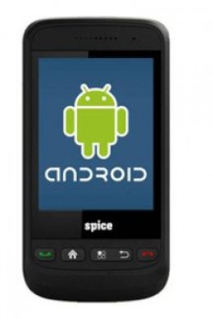

DESCRIPTION:
In our project we can control the robot by using Android mobile i.e. we are sending the commands from our android mobile through Bluetooth, then the robot receives (acts as receiver) the signals, according to the commands being received from the mobile based on that the direction of the robot is controlled .
This project is designed around a Microcontroller which forms the control unit of the project. According to this project, an android mobile is used to transmit the control signals, which controls the direction of the robot. In the same way, Bluetooth which is placed on the robot receives the commands according to which the direction of the robot is controlled. The microcontroller plays important role in controlling the direction according to commands being received at the Receiver side i.e... Robot section.
BLUETOOTH TECHNOLOGY:
Bluetooth was selected as our way of communicating PDA/Mobile with a central system. The reason Bluetooth was selected over Bluetooth for various reasons. First of all, Bluetooth security is less complex and more stable than that of Wi-Fi. Bluetooth manages a security measure of only permitting certain selected devices to interact with them; Wi-Fi in the other hand establishes a WEP key that has been known to be cracked. Another reason that Bluetooth was selected over Wi-Fi is that Bluetooth has a shorter range of signal emission than Wi-Fi. This is a pro because the shorter the range the less the amount intruders that will try to infiltrate your home system.
Android:
Android is a software stack for mobile devices that includes an operating system, middleware and key applications. The Android SDK provides the tools and APIs necessary to begin developing applications on the Android platform using the Java programming language.
HARDWARE COMPONENTS:
- Microcontroller (AT89S52)
- Bluetooth
- Android mobile
- Motors
- Motor Drivers
- LCD Display

SOFTWARE:
- Kiel U vision
- Embedded ‘C’
- Express PCB
- ISP
- Andoid.sdk

ADVANTAGES:
- Controlling robot position using Bluetooth.
APPLICATIONS:
- Any robotic applications
- This project finds its place in places where one wants to control the direction of any automated device using wireless communication.
- Industrial applications

RESULT:
By this project we can implement the robot controlled using android mobile.

